**College Algebra Name: ________________________**

**Unit 2B LT 2.6 Solving Practice Day 2 Date: _____________ Period: _____**

**Solve each equation. Check your answers.**

1)  2) 

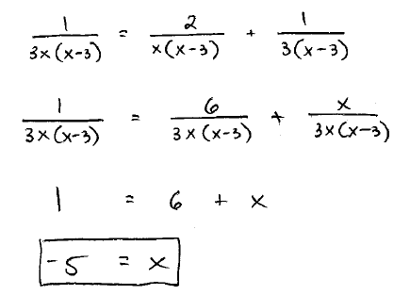

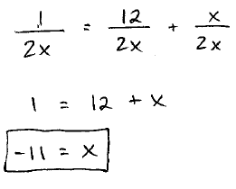

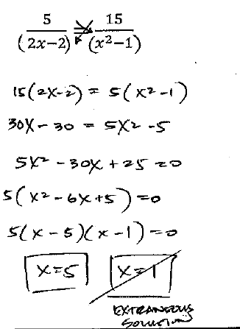3) 4) 

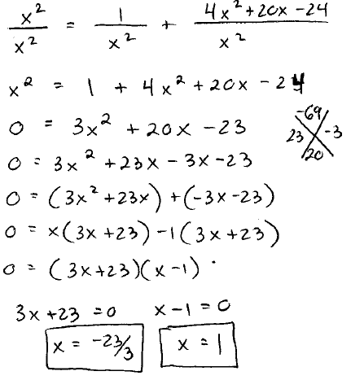

5) 6)

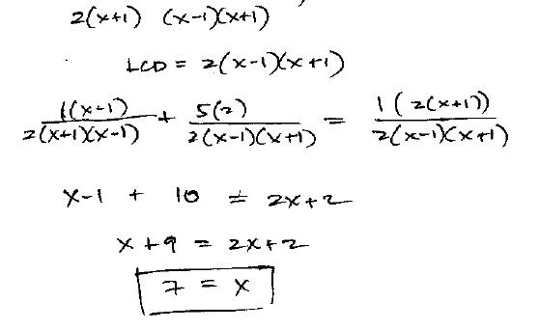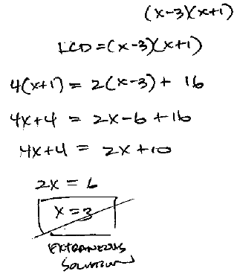

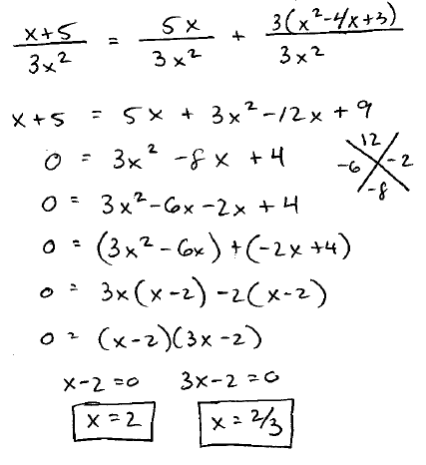7)  8) 

